**PRE- MOCK SET 5 EXAMINATIONS, 2024**

**PRIMARY SEVEN SCIENCE**

**Duration: 2 Hours 15 Minutes**

**NAME: ______________________________________________ STREAM: _________**

INDEX NO.

EMIS NO.

**SECTION A**

1. Name the type of cloud which is furthest in the sky.

………………………………………………………………………………………………......

1. Mention any one way of preventing diseases without using drugs.

………………………………………………………………………………………………......

1. Give a reason of mulching banana plantations.

………………………………………………………………………………………………......

1. Why is a lion not grouped under domestic animals?

………………………………………………………………………………………………......

1. Write PHC in full.

…………………………………………………………………………………………………

1. In the space provided below, draw a symbol of a fuse.
2. Which nutritional disease is likely to attack a child who lacks proteins in his body?

………………………………………………………………………………………………......

1. Give any one function of the liver to man.

………………………………………………………………………………………………......

1. How does a chameleon protect itself from enemies?

………………………………………………………………………………………………......

**Study the diagram and answer the questions that follow.**

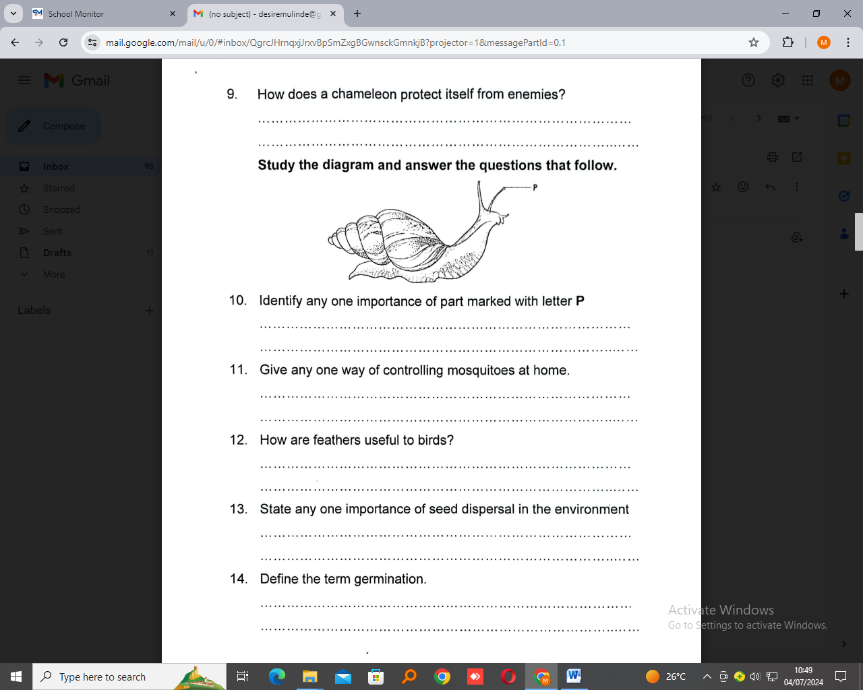

1. Identify any one importance of part marked with letter P.

………………………………………………………………………………………………......

1. Give nay one way of controlling mosquitoes at home.

…………………………………………………………………………………………………

1. How are features useful to birds?

……………………………………………………………………………………………….....

1. State any one importance of seed dispersal in the environment.

…………………………………………………………………………………………………..

1. Define the term germination.

………………………………………………………………………………………………......

1. How are incisor teeth adapted to their function?

………………………….………………………………………………………………………………......

1. What force is reduced by making rough surface smooth?

…………………………………………………………………………………………………

1. How are valves important in blood circulation?

………………………………………………………………………………………………......

1. State any one reason why poultry farmers put perches in a deep litter system.

………………………………………………………………………………………………......

1. How can polio be prevented in infants?

………………………………………………………………………………………………......

1. Mention one way of increasing the strength of an electromagnet.

………………………………………………………………………………………………......

1. Point out any one importance of demography in a country like Uganda.

………………………………………………………………………………………………….

1. Cite any one law of reflection of light.

………………………………………………………………………………………………......

1. State any one way of preventing rusting of metals.

………………………………………………………………………………………………......

1. Mention one way of controlling ticks in goats.

………………………………………………………………………………………………......

1. Give one way how a farmer can increase the fertility of soil.

………………………………………………………………………………………………......

**Study the diagram below and answer the question that follows.**

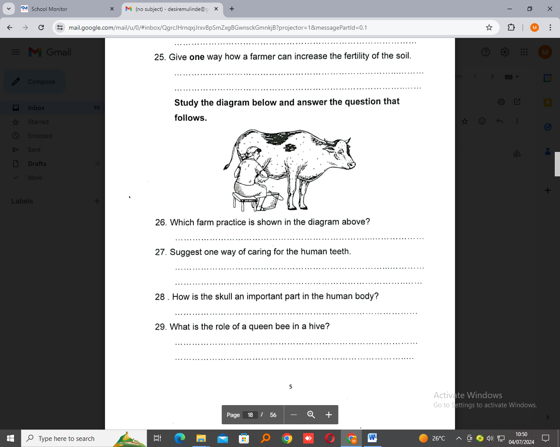

1. Which farm practice is shown in the diagram above?

………………………………………………………………………………………………......

1. Suggest one way of caring for the human teeth.

………………………………………………………………………………………………......

1. How is the skull an important part in the human body?

………………………………………………………………………………………………......

1. What is the role of a queen bee in a hive?

………………………………………………………………………………………………......

1. Name the type of leaf venation shown in the diagram below.

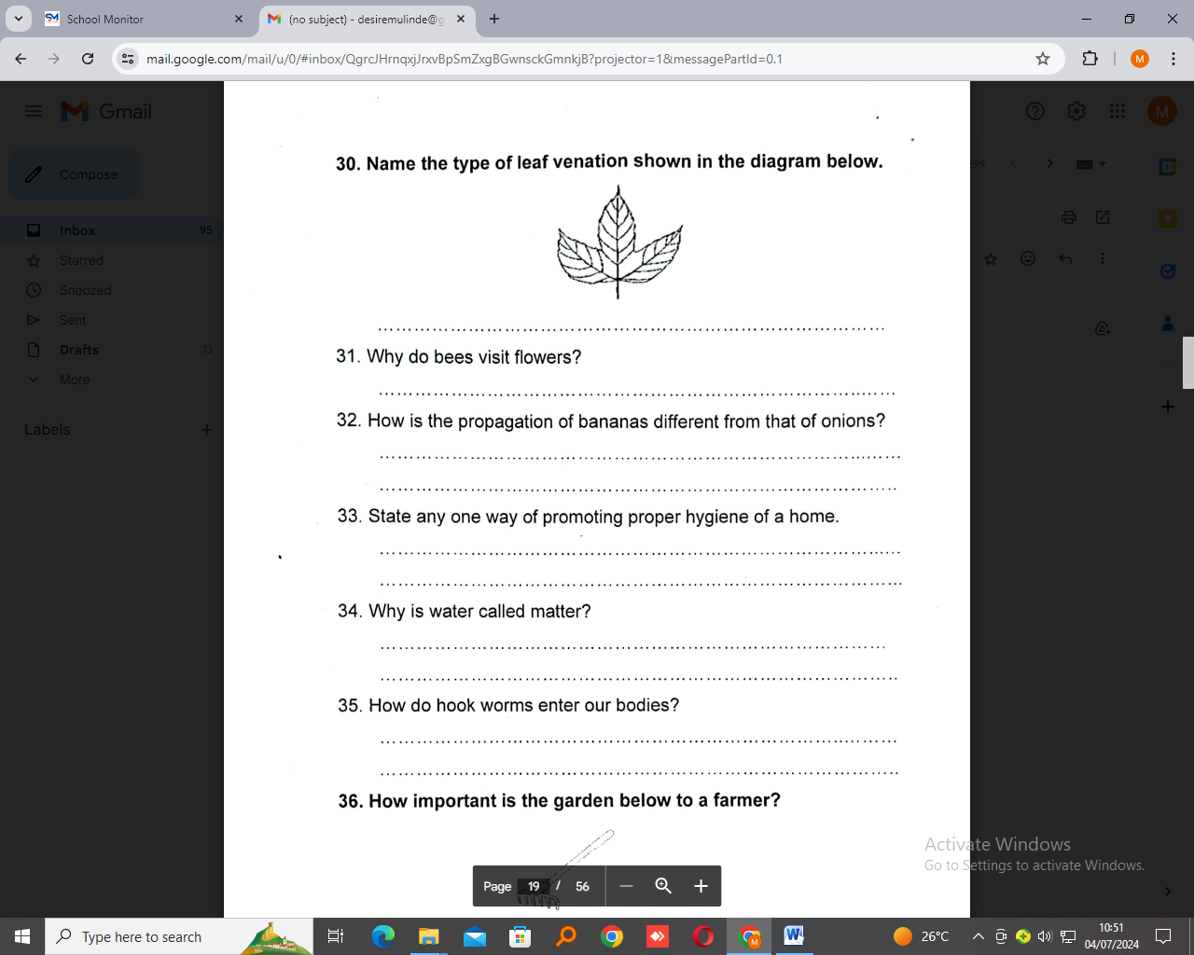 …………………………………………………………………………………..

1. Why do bees visit flowers?

………………………………………………………………………………………………......

1. How is the propagation of bananas different from that on onions?

………………………………………………………………………………………………......

1. State any one of promoting proper hygiene of a home.

………………………………………………………………………………………………......

1. Why is water called matter?

………………………………………………………………………………………………......

1. How do hook worms enter our bodies?

………………………………………………………………………………………………......

1. How important is the garden tool below to a farmer?

………………………………………………………………………………………………......

1. Identify one importance of shadows to people.

………………………………………………………………………………………………......

1. Which disease in human beings is caused by bacterium known as shigella?

………………………………………………………………………………………………......

1. Write down one way animals depend on plants.

………………………………………………………………………………………………......

1. Give any one example of wheel and axle as used in machines.

………………………………………………………………………………………………......

**SECTION B**

1. a) What are vertebrates?

….………………………………………………………………………………………………

..…………………………………………………………………………………………………

b) Mention any two vertebrate animals that use lungs for breathing.

i)………………………………………………………………………………………………....

ii)…………………………………………………………………………………………………

c) How important is blubber to sea mammals?

………………………………………………………………………………………………......

1. The diagrams below show life cycle of a housefly. Use it to answer questions that follow.

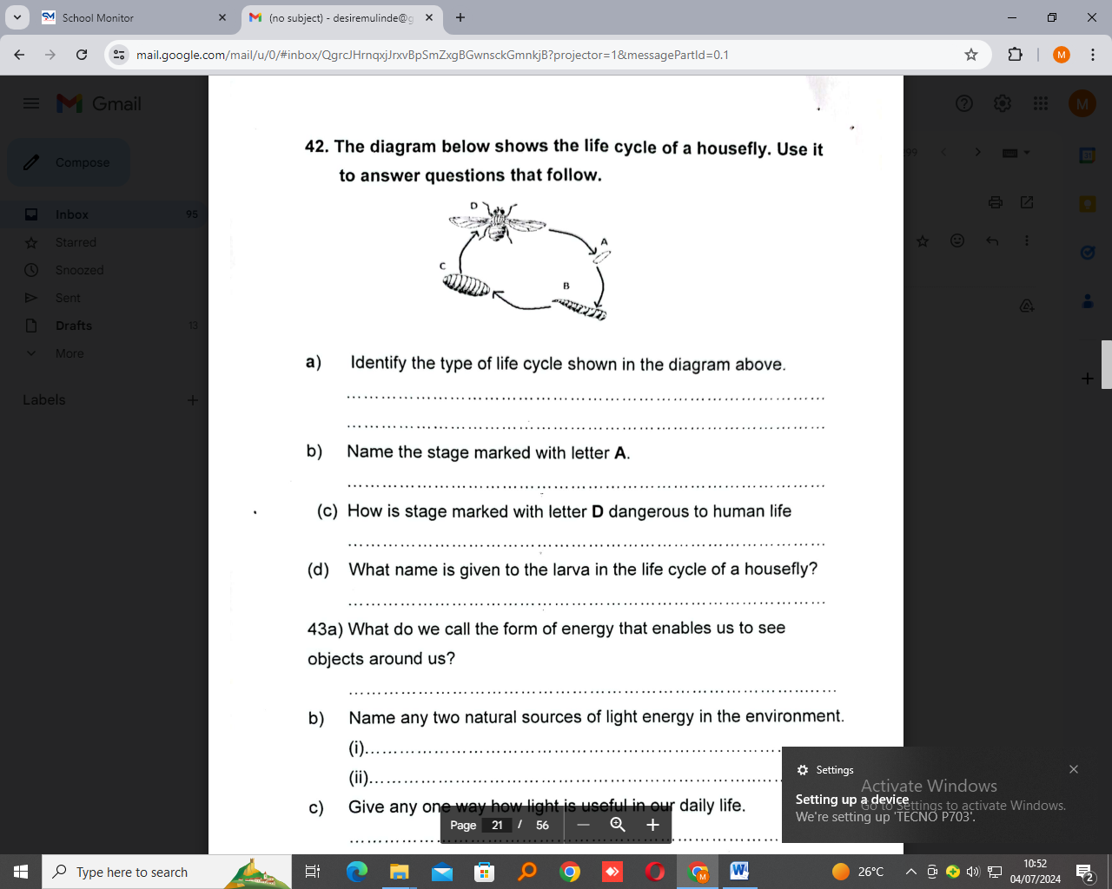

1. Identify the type of life cycle shown in the diagram above.

………………………………………………………………………………………………….

1. Name the stage marked with letter A.

..…………………………………………………………………………………………………

c) How is stage marked with letter D dangerous to human life?

……………………………………………………………………………………………….....

d) What name is given to the larva in the life cycle of a housefly?

…………………………………………………………………………………………………..

1. a) What do we call the form of energy that enables us to see objects around us?

..………………………………………………………………………………………………....

b) name any two natural sources of light energy in the environment.

i)………………………………………………………………………………………………....

ii)…………………………………………………………………………………………………

1. Give any one way how light is useful in our daily life.

…………………………………………………………………………………………………..

1. a) Mention any two examples of energy resources in the environment.

i)………………………………………………………………………………………………....

ii)…………………………………………………………………………………………………

b) Give one practice which pollutes air in the environment.

…………………………………………………………………………………………………

c) How does the use of hydroelectricity useful in the conservation of the environment?

....………………………………………………………………………………………………..

1. **Breathing is the inhaling and exhaling of air. Study the table below and complete it correctly.**

|  |  |  |
| --- | --- | --- |
| **Composition of air** | **Inhaled air by percentage** | **Exhaled air by percentage** |
| Carbon dioxide | ………………………… | 4% |
| ………………………… | 21% | 16% |
| Nitrogen | 78% | ………………………… |
| Rare gases | ………………………… | 0.97% |

1. a) Give a reason why we give first aid to casualties.

………………………………………………………………………………………………....

b) State any two materials used in giving first aid.

i)………………………………………………………………………………………………....

ii)…………………………………………………………………………………………………

c) State one quality of a good first aider

.………………………………………………………………………………………………….

1. a) Name any one dangerous substance found in tobacco.

………………………………………………………………………………………………...

b) Name any two types of smoking.

i)………………………………………………………………………………………………....

ii)…………………………………………………………………………………………………

c) Give nay one effect of smoking to the health of a pregnant woman.

…………………………………………………………………………………………………

1. **The diagram below shows a simple machine, use it to answer questions that follow.**

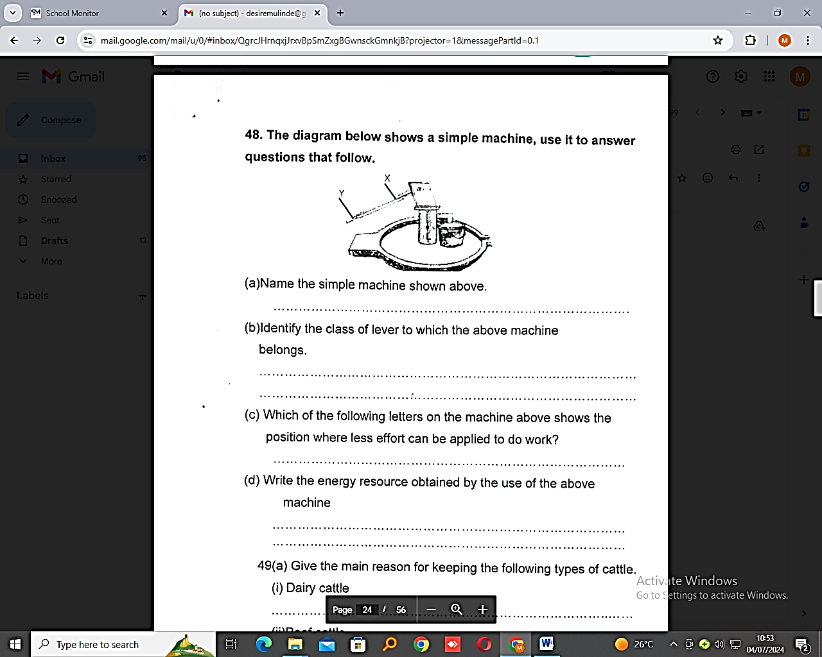

1. Name the simple machines shown above.

…………………………………………………………………………………………………

b) Identify the class of lever to which the above machine belongs.

…………………………………………………………………………………………………

c) Which of the following letters on the machine above shows the position where less effort can be applied to do work?

…………………………………………………………………………………………………..

1. Write the energy resource obtained by the use of the above machine.

………………………………………………………………………………………………….

1. a) Give the main reason for keeping the following types of cattle.

i)Dairy cattle………………………………………………………………………………

…………………………………………………………………………………………………

ii) Beef cattle……………………………………………………………………………………

…………………………………………………………………………………………………

c) Identify any one disease of cattle.

……………………………………………………………………………………………….

d) How is a lactometer important to a cattle farmer?

…………………………………………………………………………………………………..

1. Below is a diagram of a structure on a poultry farm. Use it to answer the questions that follow.

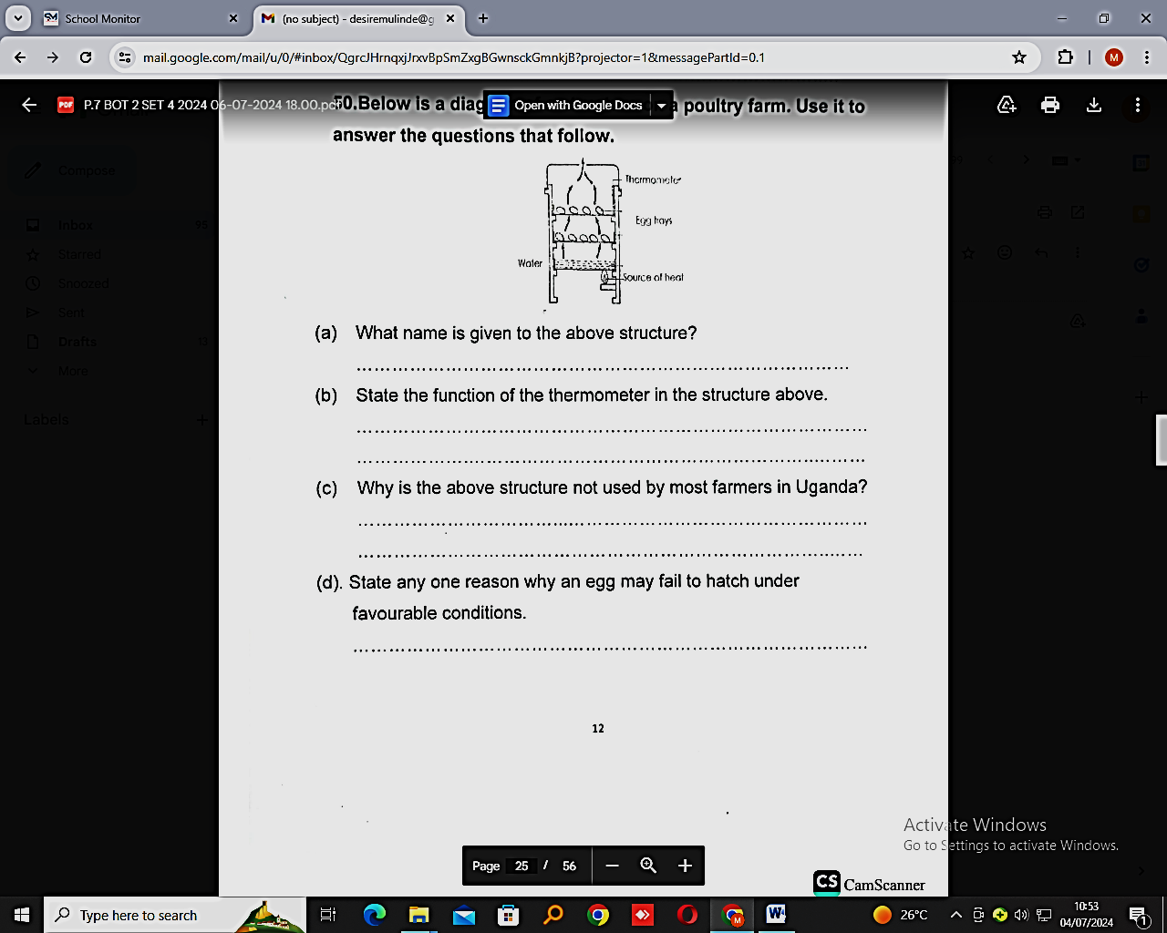

1. What name is given to the above structure?

………………………………………………………………………………………………....

b) State the function of the thermometer in the structure above.

…………………………………………………………………………………………………

…………………………………………………………………………………………………

c) Why is the above structure not used by most farmers in Uganda?

…………………………………………………………………………………………………..

d) State any one reason why an egg may fail to hatch under favourable conditions.

…………………………………………………………………………………………………..

1. A stone has a mass of 30g. find its volume if its density is 10g/cc. (2mrks)

………………………………………………………………………………………………....

b) Identify one method used in finding the volume of irregular objects like a stone.

…………………………………………………………………………………………………

c) Give a reason why some objects float on water.

…………………………………………………………………………………………………..

1. Below is a diagram of a fungus. Use it to answer the questions that follow.

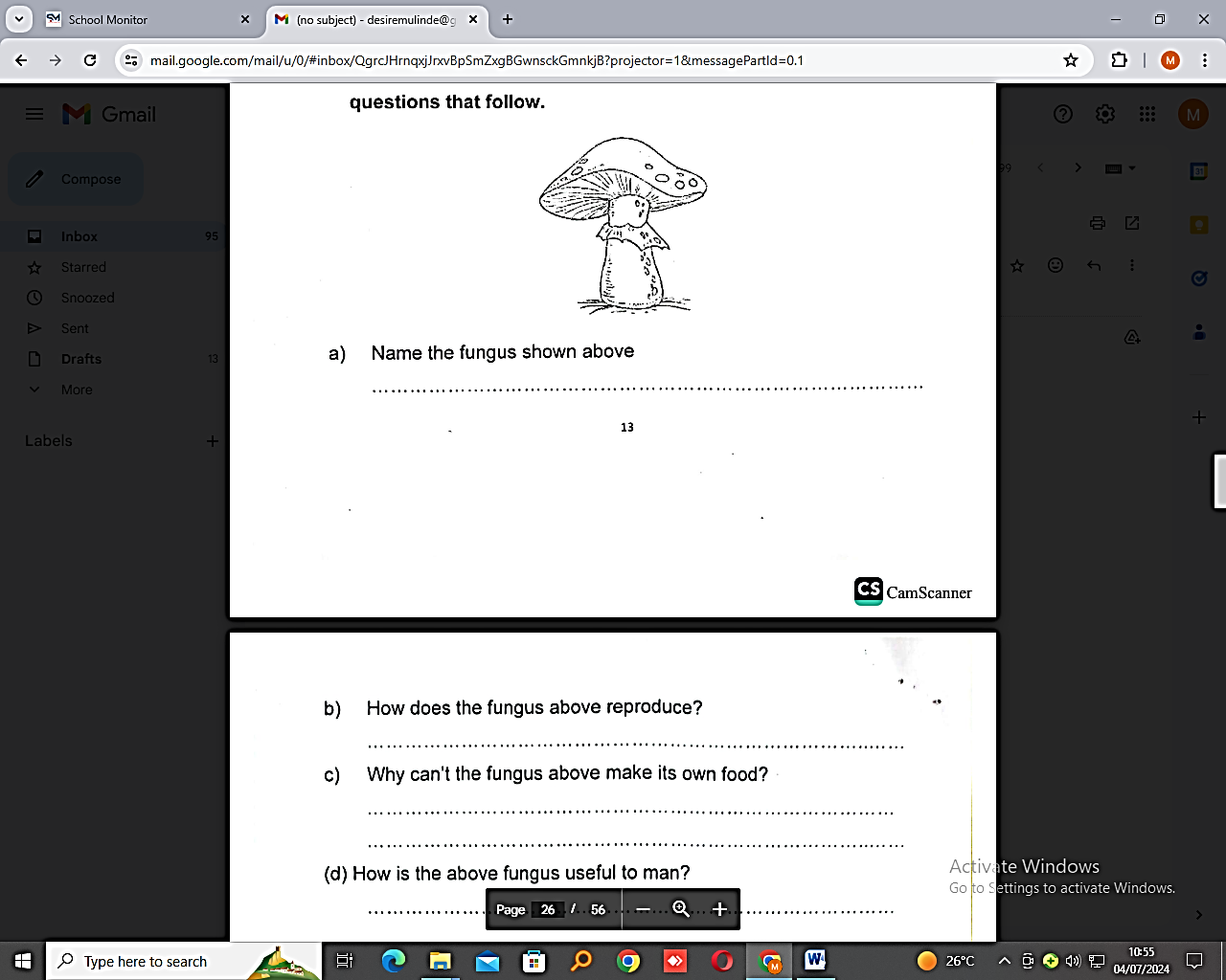

1. Name the fungus shown above.

………………………………………………………………………………………………

1. How does the fungus above reproduce?

………………………………………………………………………………………………

1. Why can’t the fungus above make its own food?

……………………………………………………………………………………………...

1. How is the above fungus useful to man?

………………………………………………………………………………………………

1. a) Define the following terms as used in sound.

i) Volume

………………………………………………………………………………………………….

..…………………………………………………………………………………………………

ii) Echo

…………………………………………………………………………………………………

…………………………………………………………………………………………………..

1. Which body organ uses sound as a form of energy to perform its function?

………………………………………………………………………………………………

1. Mention any one natural source of sound in the environment.

………………………………………………………………………………………………

1. a) Give any two factors which affect the rate of transpiration.

i)………………………………………………………………………………………………....

ii)…………………………………………………………………………………………………

1. How important is transpiration to plants?

………………………………………………………………………………………………

1. Name the process in animals that are similar to transpiration.

………………………………………………………………………………………………

1. Match the following correctly.

**List A LIST B**

Skin Bile pigments

Kidney Sweat

Lungs Urine

Liver Carbon dioxide

i) Skin…………………………………………………………………………………………

ii) Kidney ……………………………………………………………………………………….

iii) Lungs ……………………………………………………………………………………

iv) Liver ………………………………………………………………………………………

**END**